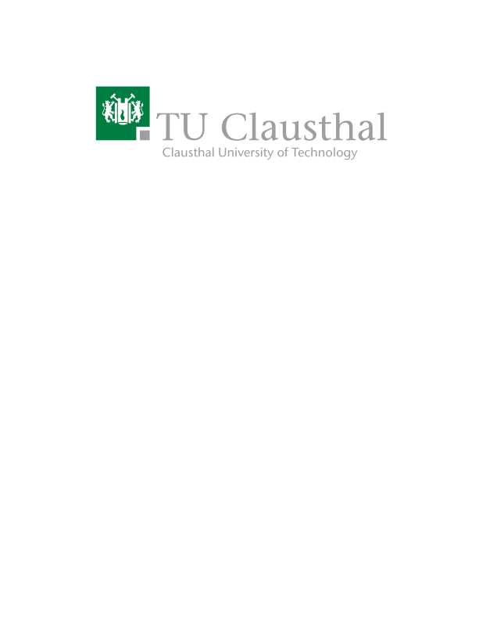
Drum Vibration Monitoring With Vibration Sensor
Type | Research Track, Bachelor Thesis, Master Thesis
Credits | 30 CPs
Start date | 01.11.2023

Description
In this project, your task is to install a vibration sensor on the drum of an eddy current separator machine (An eddy current separator machine is a specialized equipment designed to separate non-ferrous metals, such as aluminum, copper, and brass, from mixed materials. It utilizes the phenomenon of eddy currents) to measure its vibration rate. By capturing and recording the vibration data, you will gain insights into the drum's operational behaviour and identify optimal working frequencies. The project involves hardware setup, sensor data acquisition, and data recording using microcontrollers like Raspberry Pi.

Prerequisites
- Programming Skills: Python
- Sensor Basics: Familiarity with the working principles of sensors
- Microcontroller Skills: Familiarity with the operating principles of Raspberry Pi is essential for data acquisition and processing.

Tasks
- Research and Understanding: Study the principles of eddy current separators, their components, and the significance of monitoring drum vibrations.
- Sensor Mounting: Determine the optimal location and method for securely attaching the vibration sensor to the drum's surface.
- Microcontroller Integration: Learn how to interface the sensor with the microcontroller.
- Data Acquisition Setup: Program the microcontroller to read and capture vibration data from the sensor.
- Data Logging and Storage: Decide on a storage format, such as saving data to a CSV file on the microcontroller or an external device.
- Data Analysis: Transfer the recorded data to a computer and utilize data analysis tools (e.g., Python libraries) to process and visualize the vibration data.

Resources
- S Shankar (2000). Can one control the vibration of a drum? - Link.
- G Van Rossum, FL Drake Jr (1995). Python tutorial – Link.
- JA Thie – Nuclear Technology (1979). Core motion monitoring – Link.
- JH Davies (2008). MSP430 microcontroller basics – Link.
- YR Smith, JR Nagel, RK Rajamani (2019). Eddy current separation for recovery of non-ferrous metallic particles – Link.

Contact
Shohreh Kia<shohreh.kia@tu-clausthal.de>

